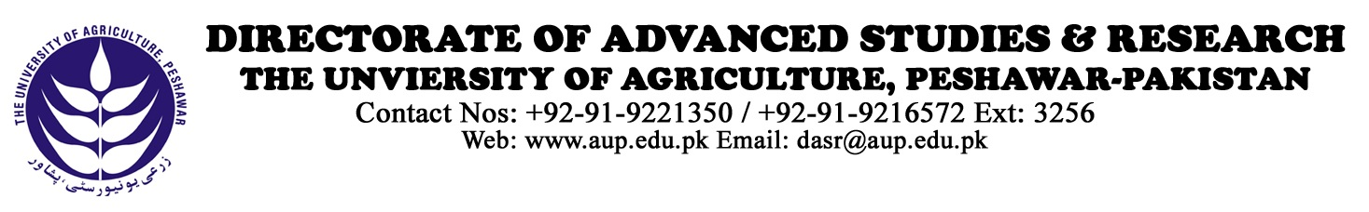

The Controller of Examinations
The University of Agriculture,
Peshawar

Through: Director Advanced Studies and Research

Subject: Comprehensive Oral Examination of Mr./Ms. _____________

Reference Notification No .________________dated_________ Mr./Ms________________ Class No. ________ Session ____________University registration No.___________________ of the Department/ Institute has passed the Comprehensive Examination. Under University regulation No. 36.3 page 41 (Rules and Regulations 2017 onwards) the following committee is proposed for oral comprehensive examination.

- Dean Faculty of ______________________________________
- Chairman Department of _______________________________
- Director Advanced Studies and Research
- Examiners of the Written Comprehensive
  - ______________________________(Major Field I)
  - ______________________________(Major Field II)
  - ______________________________( Minor Field III)

Prof. Dr.________________________________

Major Supervisor/Convener of Oral Comprehensive
Department of ______________________________ Chairman of the Department:

Director Advanced Studies & Research

Controller of Examinations

Two nominees to be filled by the Vice Chancellor from relevant discipline(s)

- ______________________________

- ______________________________

